TASK 1.

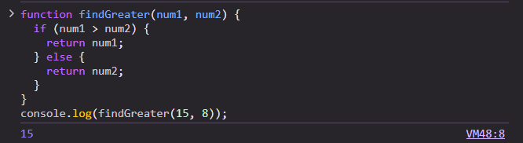

TASK 2.

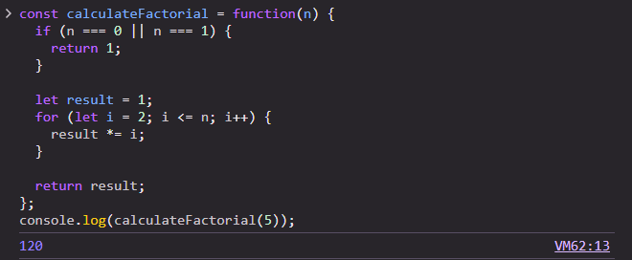

TASK 3.

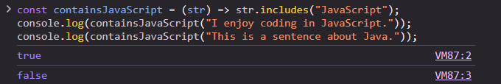

TASK 4.

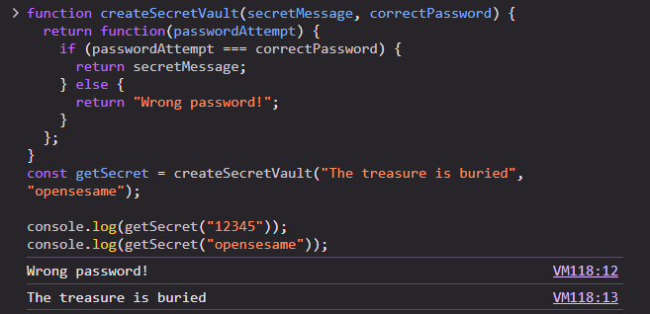

**Part 1 – Functions, Scope, and Closures**

EXAMPLE 1

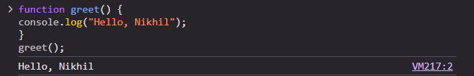

EXAMPLE 2

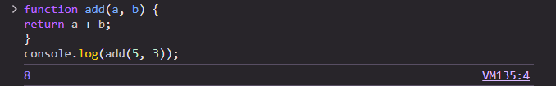

EXAMPLE 3

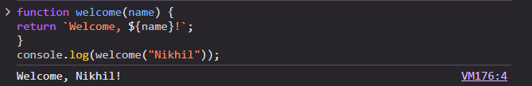

EXAMPLE 4

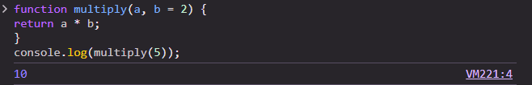

**2. Function Expressions**

EXAMPLE 2

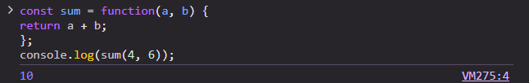

EXAMPLE 3

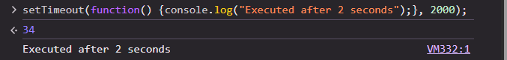

EXAMPLE 4

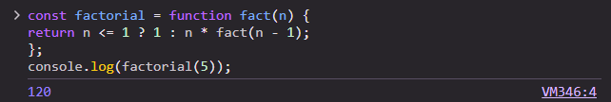

**3. Arrow Functions**

EXAMPLE 2

